DCC-GARCH correlation: USDJPY and USDCAD
Method 09 / GARCH(1,1) + Engle DCC / Alpari D1 full available history

Study setup
Logical pair: USDJPY , USDCAD
Broker symbols: USDJPY_i , USDCAD_i
Snapshot: 2026-11-03_majors_alpari_D1
Timeframe: D1
Matched return window: 1999-01-05 to 2026-11-02 (UTC bar dates)
Matched return count n: 7186
Dropped unfinished last bar dated 2026-11-03 UTC after a tick-volume check against the prior complete day.
USDJPY GARCH(1,1): mu=0.000112, omega=0.005024, alpha=0.052093, beta=0.935204
USDCAD GARCH(1,1): mu=-0.000009, omega=0.001260, alpha=0.043668, beta=0.951179
DCC: a=0.031080, b=0.957040, a+b=0.988120
Burn-in ignored in path summaries and chart: first 60 updates
Complete matched rows (Excel): USDJPY-USDCAD_DCC_D1.xlsx
Complete matched rows (HTML table): USDJPY-USDCAD_DCC_D1_data.html

Method carried forward
DCC-GARCH first fits a constant-mean GARCH(1,1) on each matched daily log return of close, ln(close_t / close_t-1), then updates Engle (2002) dynamic conditional correlation on the standardised shocks z = residual / conditional sigma. Quotes are not inverted. Correlation targeting sets Q_bar to the sample correlation of z; a and b are estimated by maximising the bivariate Gaussian DCC likelihood with a >= 0, b >= 0, and a + b < 1. Path summaries ignore the first 60 updates. The headline is rho on the last day. Same-sample Pearson r on log returns is a side check only. A high |rho| does not prove cause, lead-lag, or a trading signal.

Results
Latest DCC rho: 0.325417
Post-burn-in path (n=7126): mean=0.113741, median=0.130194, min=-0.595892, max=0.573547, std=0.203852
Share of post-burn-in days with |rho| >= 0.4: 7.70%; |rho| >= 0.7: 0.00%
Same-sample Pearson r: 0.027603
Latest rho minus r: 0.297814

Conclusion
Over 7186 matched daily log-return rows for USDJPY and USDCAD (broker quote directions unchanged), latest DCC rho is 0.3254 (positive, weak conditional linear link in this sample) with fitted a=0.0311, b=0.9570 (a+b=0.9881). After a 60-day burn-in, path mean is 0.1137 and std is 0.2039. Same-sample Pearson r is 0.0276 (latest rho minus r = 0.2978). This does not establish cause, lead-lag, or a lasting trading rule.

Charts
Daily closes

Daily log returns
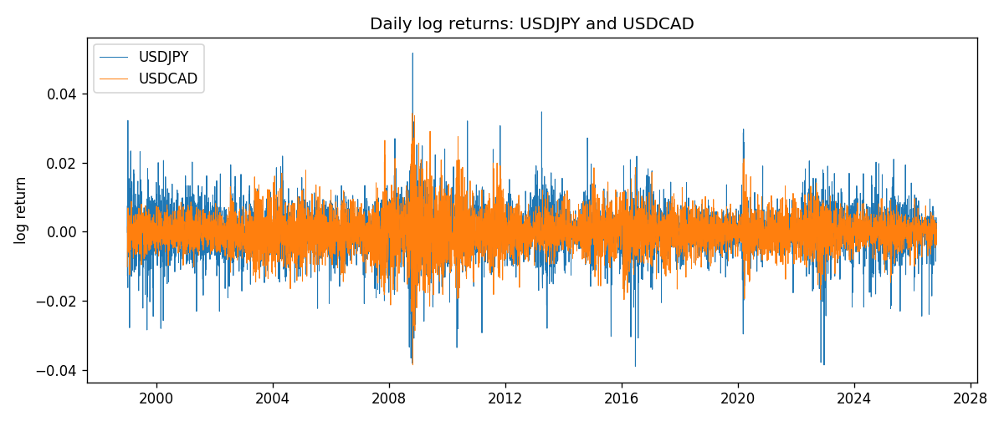
DCC rho path with Pearson r reference
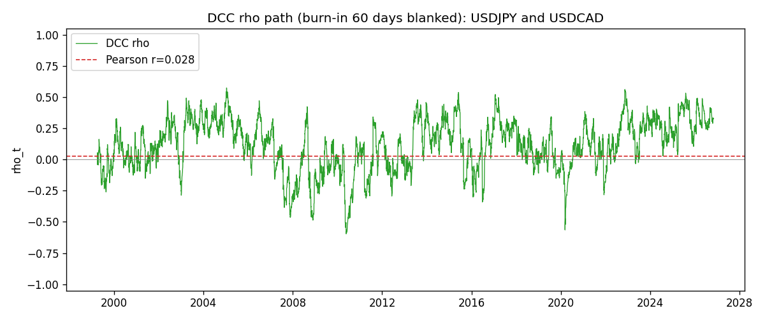

Data report
Every matched row that entered the DCC recursion is stored in the sibling Excel workbook named USDJPY-USDCAD_DCC_D1.xlsx. Embedding all rows as a Word table is impractical at this length; the Word file holds the column list, column summaries, and the first and last 15 matched rows.
Columns: time, USDJPY_open, USDCAD_open, USDJPY_high, USDCAD_high, USDJPY_low, USDCAD_low, USDJPY_close, USDCAD_close, USDJPY_tick_volume, USDCAD_tick_volume, USDJPY_spread, USDCAD_spread, USDJPY_real_volume, USDCAD_real_volume, USDJPY_log_return, USDCAD_log_return, USDJPY_sigma, USDCAD_sigma, USDJPY_z, USDCAD_z, q11, q22, q12, rho_t
Column summaries (matched calculation rows)
column | count | mean | std | min | 25% | 50% | 75% | max
USDJPY_open | 7186 | 113.80748 | 19.222412 | 75.693 | 104.39025 | 110.981 | 120.70625 | 163.824
USDCAD_open | 7186 | 1.266789 | 0.16892251 | 0.9168 | 1.118445 | 1.2985 | 1.37213 | 1.6183
USDJPY_high | 7186 | 114.30511 | 19.284087 | 76.001 | 104.8685 | 111.4395 | 121.2675 | 163.978
USDCAD_high | 7186 | 1.2716872 | 0.16888037 | 0.9336 | 1.122975 | 1.303895 | 1.37655 | 1.619
USDJPY_low | 7186 | 113.28446 | 19.150257 | 75.402 | 103.88 | 110.53 | 120.1715 | 163.628
USDCAD_low | 7186 | 1.2622311 | 0.16895752 | 0.9056 | 1.114125 | 1.293555 | 1.367815 | 1.6102
USDJPY_close | 7186 | 113.82065 | 19.237762 | 75.811 | 104.38275 | 111.018 | 120.69375 | 163.851
USDCAD_close | 7186 | 1.2668036 | 0.16889539 | 0.916 | 1.118165 | 1.29848 | 1.372395 | 1.6137
USDJPY_tick_volume | 7186 | 106329.64 | 179429.89 | 149 | 9948.5 | 53187 | 92874.5 | 1803508
USDCAD_tick_volume | 7186 | 81037.769 | 147318.12 | 37 | 5546.5 | 40944 | 71631 | 1410818
USDJPY_spread | 7186 | 20.270804 | 17.617829 | 0 | 6 | 11 | 30 | 50
USDCAD_spread | 7186 | 23.436682 | 18.263202 | 0 | 9 | 17 | 40 | 60
USDJPY_real_volume | 7186 | 3.4776211e+10 | 1.6092546e+11 | 0 | 0 | 0 | 0 | 3.8834203e+12
USDCAD_real_volume | 7186 | 1.8381818e+10 | 9.6701063e+10 | 0 | 0 | 0 | 0 | 2.5751613e+12
USDJPY_log_return | 7186 | 5.053e-05 | 0.00620694 | -0.03908203 | -0.00319936 | 0.00011986 | 0.0034094 | 0.05184024
USDCAD_log_return | 7186 | -1.555e-05 | 0.00514357 | -0.03859748 | -0.00283709 | 4.741e-05 | 0.00272359 | 0.03436319
USDJPY_sigma | 7186 | 0.00599387 | 0.00174119 | 0.00337358 | 0.0047757 | 0.00569422 | 0.00679946 | 0.01883699
USDCAD_sigma | 7186 | 0.0047945 | 0.00181367 | 0.00251035 | 0.00365456 | 0.00435958 | 0.00534751 | 0.01852647
USDJPY_z | 7186 | -0.00906057 | 1.0002803 | -6.5295109 | -0.56507608 | 0.00168936 | 0.58066029 | 7.1022111
USDCAD_z | 7186 | 0.0015445 | 1.000093 | -4.0694169 | -0.62860696 | 0.01107451 | 0.61213914 | 6.4149327
q11 | 7186 | 1.0011877 | 0.23167821 | 0.56110544 | 0.84336094 | 0.96788703 | 1.1117454 | 2.312333
q22 | 7186 | 1.0007165 | 0.18524749 | 0.63111155 | 0.88410876 | 0.97313055 | 1.0781395 | 2.5448859
q12 | 7186 | 0.10588353 | 0.22826284 | -1.1724 | -0.01899102 | 0.12010708 | 0.25731284 | 0.95072747
rho_t | 7186 | 0.11338296 | 0.20318569 | -0.5958916 | -0.02051264 | 0.1293906 | 0.26923171 | 0.57354699
First 15 matched rows (selected columns)
time | USDJPY_log_return | USDCAD_log_return | USDJPY_sigma | USDCAD_sigma | USDJPY_z | USDCAD_z | q11 | q22 | q12 | rho_t
1999-01-05 | -0.00017868311 | -0.010131666 | 0.011227291 | 0.0045245701 | -0.025886407 | -2.2372496 | 1 | 1 | 0.10633807 | 0.10633807
1999-01-06 | 0.0075660159 | -0.0003306769 | 0.010880773 | 0.0049063998 | 0.6850676 | -0.065547824 | 0.96894104 | 1.1244834 | 0.10483307 | 0.10043223
1999-01-07 | -0.012851583 | 0.0015202092 | 0.010682547 | 0.0047987473 | -1.2135246 | 0.31868363 | 0.95378184 | 1.0881894 | 0.10019714 | 0.098350948
1999-01-08 | -0.0047719894 | -0.0020495197 | 0.010769369 | 0.0047044458 | -0.45350293 | -0.43372732 | 0.97045698 | 1.0564774 | 0.085136489 | 0.084080926
1999-01-11 | -0.016195423 | -0.0035137769 | 0.010498062 | 0.0046215882 | -1.5533699 | -0.75833322 | 0.94703838 | 1.0288181 | 0.088855631 | 0.09001852
1999-01-12 | 0.032310364 | 0.0066194721 | 0.010836223 | 0.0045802439 | 2.9713686 | 1.4472035 | 0.99322803 | 1.0143733 | 0.12291282 | 0.12245423
1999-01-13 | 0.0081373171 | 0.0045420214 | 0.012818905 | 0.0046903154 | 0.62605706 | 0.97031738 | 1.2368435 | 1.0477695 | 0.25254432 | 0.22184383
1999-01-14 | 0 | 0.0069376546 | 0.012551268 | 0.0046856664 | -0.0089195059 | 1.4825485 | 1.2077706 | 1.0438996 | 0.26183851 | 0.23319107
1999-01-15 | 0.0055343401 | -0.0056905671 | 0.012158528 | 0.0048079958 | 0.44597412 | -1.1816762 | 1.1677675 | 1.0792457 | 0.25144228 | 0.2239752
1999-01-18 | 8.7600193e-05 | 0.00098344542 | 0.011844202 | 0.0048501306 | -0.0020559355 | 0.20463747 | 1.135662 | 1.0881601 | 0.22552471 | 0.2028725
1999-01-19 | -0.0056219403 | 0.002748513 | 0.01147596 | 0.0047480824 | -0.49964372 | 0.58077888 | 1.0987543 | 1.0545945 | 0.21708642 | 0.20166922
1999-01-20 | -0.0053879917 | -0.0059646885 | 0.01119729 | 0.0046799222 | -0.49118518 | -1.2725885 | 1.071191 | 1.0316527 | 0.20000491 | 0.19025692
1999-01-21 | 0.0084664056 | -0.0042823796 | 0.010923984 | 0.0047441797 | 0.76478092 | -0.9007472 | 1.0445512 | 1.0495462 | 0.21210328 | 0.20257308
1999-01-22 | 0.0060412564 | 0.0025057712 | 0.010758227 | 0.0047256532 | 0.55114148 | 0.5321686 | 1.0297358 | 1.0415544 | 0.18284459 | 0.17655428
1999-01-25 | -0.0073594164 | 0.00085579808 | 0.01051541 | 0.0046522757 | -0.71051606 | 0.18590281 | 1.0068192 | 1.0174913 | 0.18536862 | 0.18314502
Last 15 matched rows (selected columns)
time | USDJPY_log_return | USDCAD_log_return | USDJPY_sigma | USDCAD_sigma | USDJPY_z | USDCAD_z | q11 | q22 | q12 | rho_t
2026-10-13 | -0.0018932826 | -0.0046395653 | 0.0048715871 | 0.0028876525 | -0.41161815 | -1.603549 | 0.87802934 | 0.82271491 | 0.26723595 | 0.31442399
2026-10-14 | 7.5800166e-05 | 0.0015184751 | 0.0047860722 | 0.0029989505 | -0.0075533633 | 0.50936091 | 0.85745524 | 0.87916888 | 0.27753303 | 0.3196486
2026-10-15 | -0.0018524319 | -0.0036101503 | 0.0046823852 | 0.0029635242 | -0.41952615 | -1.2151334 | 0.83250093 | 0.86134359 | 0.26675398 | 0.31501434
2026-10-16 | -0.00037976126 | -0.0034322068 | 0.0046051642 | 0.0030076469 | -0.10677412 | -1.1381435 | 0.814087 | 0.8821113 | 0.27240142 | 0.32144914
2026-10-19 | 0.0034946841 | -0.0018835331 | 0.0045109194 | 0.0030400593 | 0.7498988 | -0.61658667 | 0.79134835 | 0.89635584 | 0.26573935 | 0.31552355
2026-10-20 | -0.0022546642 | -0.0037066008 | 0.0044864705 | 0.0030116688 | -0.52750048 | -1.2277339 | 0.78670988 | 0.88154448 | 0.24121593 | 0.28965202
2026-10-21 | -0.00032883504 | -0.00084691787 | 0.0044292626 | 0.0030578275 | -0.099516825 | -0.27400002 | 0.77344117 | 0.90240104 | 0.25224483 | 0.30193179
2026-10-22 | -0.0085942669 | -0.0026307268 | 0.004342778 | 0.0030083933 | -2.0047578 | -0.87144649 | 0.75240213 | 0.87784744 | 0.2435192 | 0.29963923
2026-10-23 | 0.00035080446 | 2.85545e-05 | 0.0046998581 | 0.0030057728 | 0.050821396 | 0.012518433 | 0.85687044 | 0.8756179 | 0.28861855 | 0.33320334
2026-10-26 | 0.0041238746 | 5.7106554e-05 | 0.004600305 | 0.0029528983 | 0.87209947 | 0.02241175 | 0.83201976 | 0.84988642 | 0.27750261 | 0.33000445
2026-10-27 | 0.0027651658 | 0.0025379458 | 0.0045970022 | 0.0029017336 | 0.57716193 | 0.87775763 | 0.83179435 | 0.82527111 | 0.2674519 | 0.32280435
2026-10-28 | -0.00095679538 | -0.0038379274 | 0.0045422757 | 0.0029014183 | -0.23528878 | -1.3196492 | 0.81829384 | 0.82564335 | 0.27297078 | 0.33209725
2026-10-29 | -0.00038043789 | -0.00011436495 | 0.0044561537 | 0.0029619888 | -0.11049641 | -0.035547699 | 0.79674073 | 0.85617854 | 0.27215752 | 0.3295184
2026-10-30 | -0.0010596481 | -0.0010298736 | 0.0043687168 | 0.0029105833 | -0.26817926 | -0.35072025 | 0.77477241 | 0.83131658 | 0.26185105 | 0.32627517
2026-11-02 | 0.0026438521 | 0.00061519094 | 0.0042921952 | 0.0028686879 | 0.58988486 | 0.21761308 | 0.75560364 | 0.81130638 | 0.25478851 | 0.3254171

